 | UNIDAD DE ARCHIVO DE DATOS  Centro de Astrobiología  INTA-CSIC

MySpec-MyImg
Tools for publication of spectra and images in the Virtual Observatory

Authors: José Manuel Alacid Polo
Date: 2016-06-07
Pages: 20
Version: 1.0
Code: TN_SVO-MSMI_2014
Keywords: Spectra, images, Virtual Observatory, Data Publishing

Authors: | José Manuel Alacid Polo
Reviewed by: | Enrique Solano Márquez
Approved by: | Enrique Solano Márquez

Distribution List:
Name | Internal/External
Participants in the workshop on data publishing in the VO | External

Change Control

Version | Date | Change Description
0.1 | 2014-04-01 | Initial version
1.0 | 2016-06-07 | Changed the DB connection and the download system

Acronyms:
SVO: Spanish Virtual Observatory.
SIAP: Simple Image Access Protocol.
SSAP: Simple Spectral Access Protocol.

Reference Documents

N | Document Name | Code
1
2
3
4

Índice
MySpec-MyImg 0
Tools for publication of spectra and images in the Virtual Observatory 0
1. Introduction 8
2. Configuration 8
2.1.1 Server configuration 8
2.2 Local configuration 8
3. Installation 9
3.1 Download and Deploy the project 9
3.2 Configuration of your data set 11
4. Web application 14
4.1 Search zone 14
4.2 Private zone 16
5. VO Access 17
6. Registry (for web server implementation only) 18

- Introduction
MySpec and MyImg are applications which intend to make easier the publication of spectra and images in the Virtual Observatory.

Both spectra and Images have to be in FITS format with a standard header. The header must contain the RA and DEC keywords, both in decimal degrees.
- Configuration
DISCLAIMER: We have tested the application in Ubuntu Linux, in particular in this installation:

Ubuntu 12.04.1/Ubuntu 13.10/Ubuntu 14.04 + Tomcat 7 + Postgresql 9.3

In principle, there is no reason why you need any specific distribution or any special version of the software. Anyway, we recommend you to use the most up to date Linux version and Tomcat, PostgreSQL and Java packages.
    - Server configuration
To install and configure the application to be used for external users you need to contact your system administrator, who will need to install:

- Java JDK (http://www.oracle.com/technetwork/java/index.html)
- Web Server Tomcat (http://tomcat.apache.org/)
- Web Server Apache (http://www.apache.org/)
- Postgresql database (http://www.postgresql.org/)

The application has a private zone, which has to be set-up in the web server Apache. This private zone is in the /private/ directory.

Alternatively, you can try the:
  - Local configuration
If you are interested in installing a local version for your use only, then, it is not necessary to install Apache because we don't need to limit the access to the private part.

- Java JDK, you can download it at https://www.java.com/es/download/ or use the apt-get tool:
- sudo apt-get install default-jdk

- Tomcat7, you have to install it and launch the service:
- sudo apt-get install tomcat7
- sudo /etc/init.d/tomcat7 start

- Postgresql: Installation and configuration of the database:
- sudo apt-get install postgresql-9.3 postgresql-client-9.3
- sudo su postgres -c psql // to enter to the db
- # ALTER USER postgres WITH PASSWORD 'new_pw'; // To change the root password
- # CREATE USER user_name WITH PASSWORD 'user_pw'; // To create a user
- # CREATE DATABASE db_name OWNER user_name; // To create the database
- # \q
- Postgresql: Modification of the configuration file:
- sudo gedit /etc/postgresql/9.3/main/pg_hba.conf // To edit it

- Change
- # Database administrative login by Unix domain socket
local all postgres peer
by
- # Database administrative login by Unix domain socket
local all postgres password

- Change
- # “local” is for Unix domain socket connections only
local all all peer
by
- # “local” is for Unix domain socket connections only
local all all password

- Save and exit

- We have to create the conection pool with the database:
- sudo gedit /etc/tomcat7/context.xml

- Write after “<context>”:
- <Resource name ='jdbc/myspec' aut=”Container” type=”javax.sql.DataSource” maxActive=”20” maxIdle=”10” maxWait=”5000” username =”user_name” password=”user_pw” driverClassName=”org.postgresql.Driver” url=”jdbc:postgresql://localhost:5432/db_name”/>
- Where:
  - myspec: change by myimg depending of the case.
  - user_name is the name of the user.
  - user_pw: is the password of the user.
  - localhost: is the name of the host where you install the db.
  - db_name: is the name of the database

- We have to copy the lib 'postgresql-8.7-412.jdbc3.jar' in /usr/share/tomcat7/lib

- We have to restart the service to apply the changes
- sudo service postgresql restart
- sudo /etc/init.d/tomcat7 restart
- Installation
  - Download and Deploy the project
- Prepare your working directory in your machine/server. It has to have reading and writing permissions for the tomcat user. “chmod a+xrw directory”. Please, remember the path to the working directory (you will have to use in Sect. 3.1.1).

- Create the following three subdirectories in the working directory:
- /data ---> here you will store your data with a free structure inside
- /properties ---> A configuration file will be created here, do not touch it!
- /MyImg or /MySpec --> here you will store the MyImg.war /MySpec.war files.

- Give reading and writing permissions to the data and properties subdirectories
- chmod a+rwx data
- chmod a+rwx properties

- Unpack the .war file.
- Go to the MyImg or MySpec directories and copy MyImg.war or MySpec.war there.
- jar xvf MyImg.war
- Delete the .war file

- Here you can find the properties file:
- MySpec/WEB-INF/classes/myspec.properties (for MySpec.war)
- MyImg/WEB-INF/classes/myimg.properties (for MyImg.war)

- Open the properties file using a text editor.

    - Properties File
Include the following information in the properties file:

- name: name of the project. Only one case-dependent word. IMPORTANT: Do not forget the name assigned to the project as you will need it later.
- title: the title of the project.
- texto: the description of the project, you can use html format to give emphasis(<b></b>) and ends of line (<br>), but all in the same line.
- org: name of you institution.
- web: web page of your institution.
- email: contact email.
- path: the path to your working directory as defined at the beginning of Sec 3.1.
- version: last version of the archive.

    - Logo File
If you have an image/logo of your institution, you can include it by replacing the one you can find at:

- MyImg/images/myLogo.gif
- MySpec/images/myLogo.gif

Note that your logo must be renamed to “myLogo.gif”

Logo is supposed to be 200x100 pixel size.

    - Project Name
The project name is the one you gave in Sect. 3.1.1.

Use a text editor to open the file /MyImg/WEB-INF/web.xml (or /MySpec/WEB-INF/web.xml) and change:

<display-name>MySpec (or MyImg)</display-name>

by

<display-name>name</display-name>

where “name” is your project name.

    - Deploy the project
Once all the previous steps have been accomplished, your have to go to the MySpec/MyImg directory and execute the command:

jar cvf name.war . (note the “.” after “name.war”)

where “name” is your project name

NOTE: If you chose the “server configuration”, you may need to contact your system administrator to execute the subsequent steps:

Next step is to stop tomcat:

sudo /etc/init.d/tomcat7 stop

You have now to copy the file “name.war” (where “name” is the name of your project) in the tomcat structure /var/lib/tomcat7/webapps/ and restart tomcat:

sudo cp name.war /var/lib/tomcat7/webapps/
sudo /etc/init.d/tomcat7 start

If all the previous steps have been properly followed, you should see the project if you write in the navigator:

http://localhost:8080/name

with “name” being the name of the project (Figure 1).

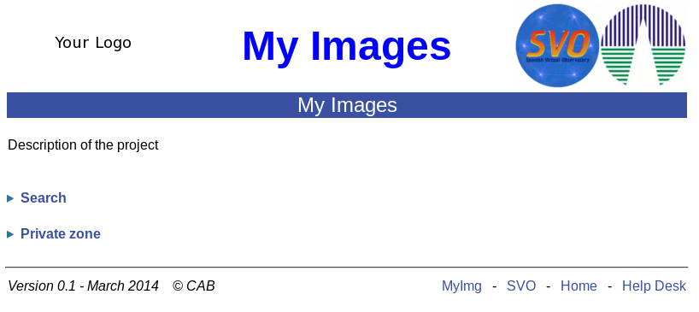
Figure 1.

Should you want to modify anything here, go back to Sect. 3.1.1

  - Configuration of your data set
Click on “Private zone” (Figure 1). After this, you should see a web page like the one shown in Figure 2.

NOTE: If you chose “server configuration”, the system will now ask you for a username and password. We advise you to contact your system administrator.

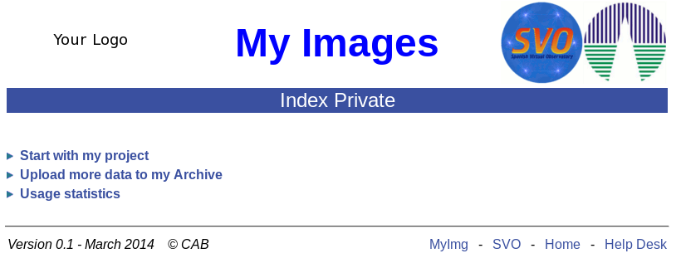
Figura 2

Click on “Start with my project”. You should see a web page like the one shown in Figure 3.

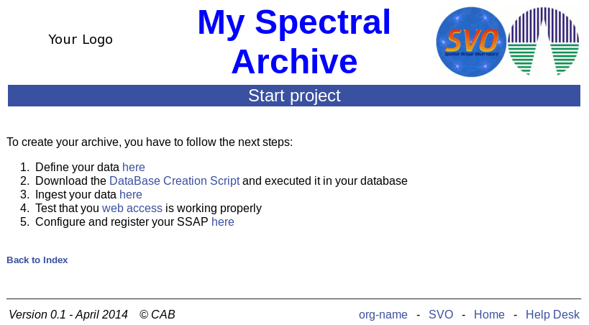
Figure 3

    - Define your data
Here we are going to describe our images / spectra. This is a very important step, so pay attention to do it correctly.

Click on “here “ in the sentence “Define your image data here” (Figure 3). After some information, a table like that displayed in Figure 4 will be shown. Include in this table all the parameters you want to use in the query or you want to display in the table of results. For each parameter you have to fill in the following information:

- Name: This is the name that will be assigned to the parameter in the database. Use only letters, and, optionally, numbers and '_'. Do not use blanks.
- Keyword: The keyword of the FITS header associated to the parameter.
- Type: Data type of this column. You can use:
  - String
  - Double
  - Integer
  - Date + Time
  - Date
  - Time
- Search: Tick if you want to use the parameter in the query form.
- Show: Tick if you want to use the parameter in the table of results.
- UCD: This is the Unified Content Descriptor used in VO services to give more information about the physical meaning of a parameter. Your can use the UCD builder at CDS to find the adequate UCD for each case (http://cds.u-strasbg.fr/UCD/cgi-bin/descr2ucd).
- Units: Write a string for the unit corresponding to this field. Leave it empty if units don't apply.
- Description: A short description of the parameter (ascii, no special characters).

NOTE: “UCD”, “Units” and “Description” are not compulsory fields.

The table allows a maximum of 30 rows (plus RA and DEC which are mandatory and given by default).
Once you move to the next step, do not change the values given in the columns “Name” and “Keyword”. The values of the rest of the columns can be subsequently modified if you need so.

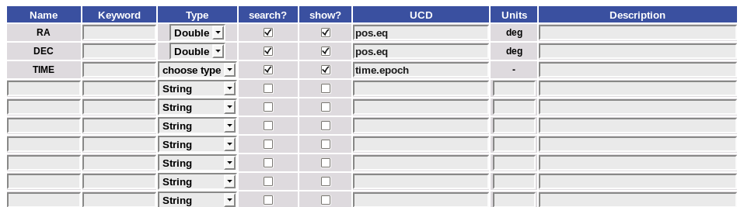
Figure 4

The system will give you a confirmation message: “The Image/Spectral configuration file has been modified!!”
Click on “Back to Index” to continue with the configuration.
    - Prepare your Data Base

Click on “DataBase Creation Script“ in the second point of Figure 3. Save the script (MyImgDB.sql or MySpecDB.sql). We recommend to save the script in the working directory (Sect. 3.1).

Open a terminal, go to the working directory and execute these commands:

psql -h host -U user -W -f MySpecDB.sql db_name (for spectra) or

psql -h host -U user -W -f MyImgDB.sql db_name (for images)

where host is where the db is (“localhost” for the local configuration); user the db user, and db_name the name of our data base. “User” and “db_name” were given in Sect. 2.2.

This will create all the necessary tables and indexes in the database.

NOTE: In the “server configuration” ask your system administrator to check whether the user you have defined in the configuration file has the necessary permissions in all the tables and indexes. If this is not the case, your can use: GRANT all TO user_name ON table, where table is “myspec”, “download”, “download_file”, “query”, “myspec_pk”.

    - Ingest your Data

Click on “here “ in the sentence “Ingest data here” (Figure 3). You will see a new page (Figure 5) with the path to the data defined in Sect. 3.1. You can modify the path and create subdirectories if you wish so. Click on “Submit”. Then, the system will upload the data to the database.

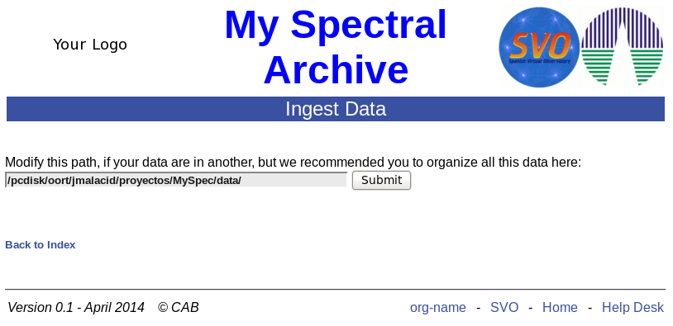
Figure 5

The system will give you information about the status of the data ingestion process (Figure 6):
- Red if the file was not inserted in the database. This happens, for instance, if another file with the same name already exists in the database.
- Orange if the data have been ingested but some error condition occurs. This is, for instance, the case when one of the keywords ingested in the database cannot be found in the FITS header. In this case the value of the keyword will be 'null'.
- Green if the data were uploaded without any problem.

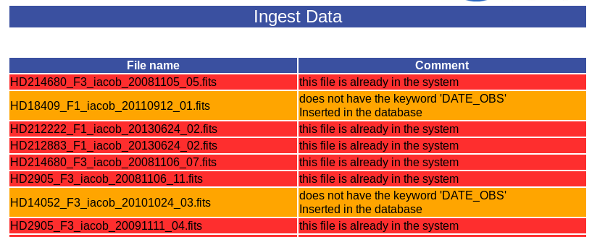
Figure 6

This is the last step in the archive building process. Click on “Back to Guide” to test it.
- Web application
  - Search zone
Clicking on “web access” (Figure 3), a web page with a query form containing the search conditions defined in Section 3.2.1 will be displayed (Figure 7).

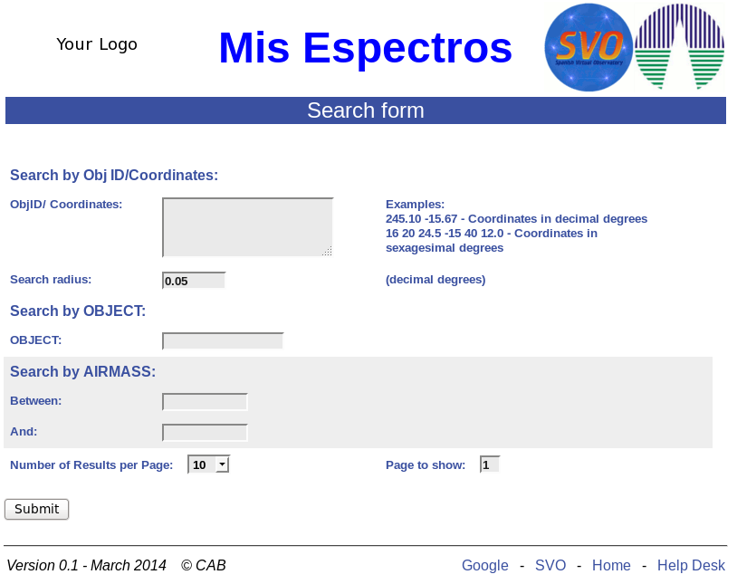
Figure 7

In the result page, you will fields you selected in Sect. 3.2.1.

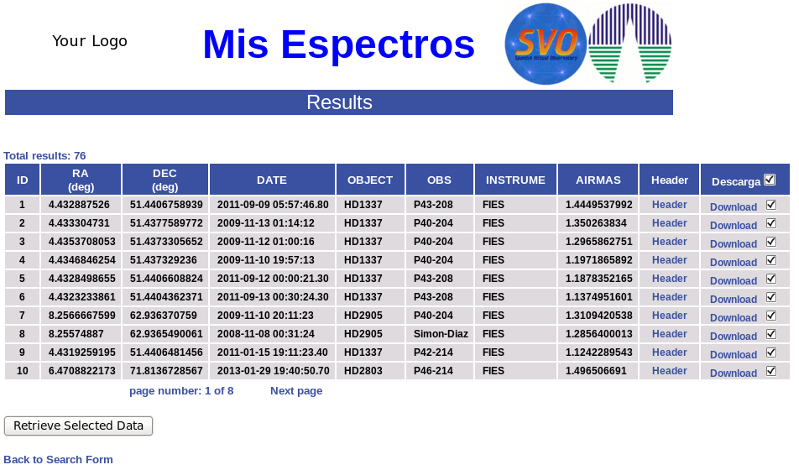
In the result page (Figure 8 and 9), the user can download the FITS files individually or in groups. Also, both the FITS header and the data (in the case of images) can be visualized by clicking on the corresponding links.
Figure 8
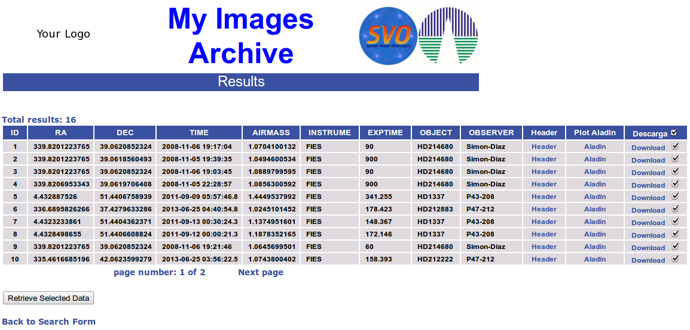
Figure 9

  - Private zone
    - Upload more data to the Archive
If you have a dynamic archive and you need to upload new data from time to time, you can do that by clicking on “Upload more data to the archive” (Figure 2). In this case you will to repeat the step described in Sect. 3.2.1.
    - Usage statistics
You can see the usage statistics of your archive by clicking on “Usage statistics” (Figure 2). After clicking, you will see two pages similar to those shown in Figures 10,11.
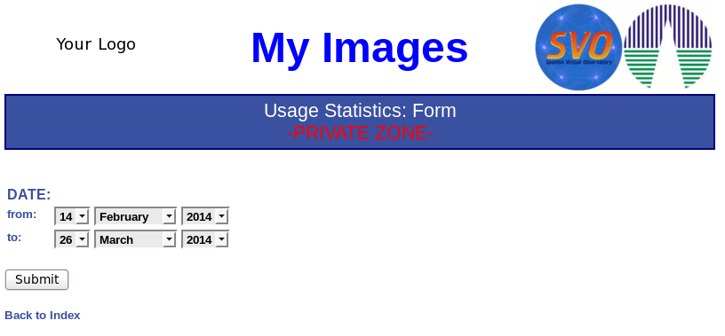
Figure 10

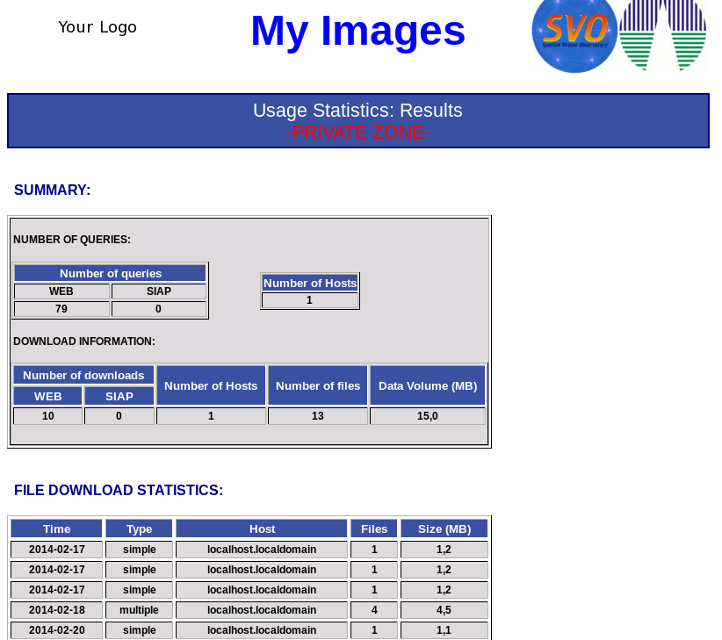
Figure 11

- VO Access
For Spectra, we must return to the the “Start project web page” and go to point 5. “Configure and register your SSAP”. There your have to change the information of the table and press submit.

The application also implements a VO access protocol: SIAP for images and SSAP for spectra.

Your can use the next url:
For images:
base_project/jsp/siap.jsp?pos=..,..&size=...

For spectral:
base_project/jsp/ssap.jsp?pos=..,..&size=...

where “base_project” is localhost:8080/name (where “name” is the name of the project) for the local configuration or the server name for the server configuration.
- Registry (for web server implementation only)

Once, you have checked that the service is working properly, you have to register it. We recommend to use the EURO-VO Registry. http://registry.euro-vo.org/

Click on “Insert Resource” and select “SimpleImageAccess” or “SimpleSpectralAccess” as Resource type.

A form will appear (Figure 12). You are requested to fill in as many fields as possible to ensure a good description of your service. Compulsory fields are marked with a red asterisk. More information on the form can be found at:
http://www.ivoa.net/documents/REC/ResMetadata/RM-20070302.pdf

Anyway, we recommend you to fill in the following fields:

Resource Type:
- Title: Title of your project
- Identifier: For instance: ivo://yourdatacenter/yourproject
- Short Name: You can use the name of your project
- Status: Select “Active”
- Password: Define a password to access the form subsequently.

Resource Curation:
- Publisher: The entity responsible for making the resource available. For instance, the name of your centre.
- Name: Again, the name of your centre

- Contact:
  - Name: Name of the person responsible for the archive
  - Email: e-mail of the person responsible for the archive.

Resource Content
- Subjects
  - Subject: For instance, “name of the project”, SIAP/SSAP, images/spectra
  - Description: Description of your archive
  - Reference URL: Related web page to your archive

Misc. Informations
- Interfaces
  - Interface Type: select ParamHTTP
  - Access URL: write your_path/jsp/siap.jsp? (see Sect. 5).
  - Access URL Use: select Base

and now click on “Submit”.

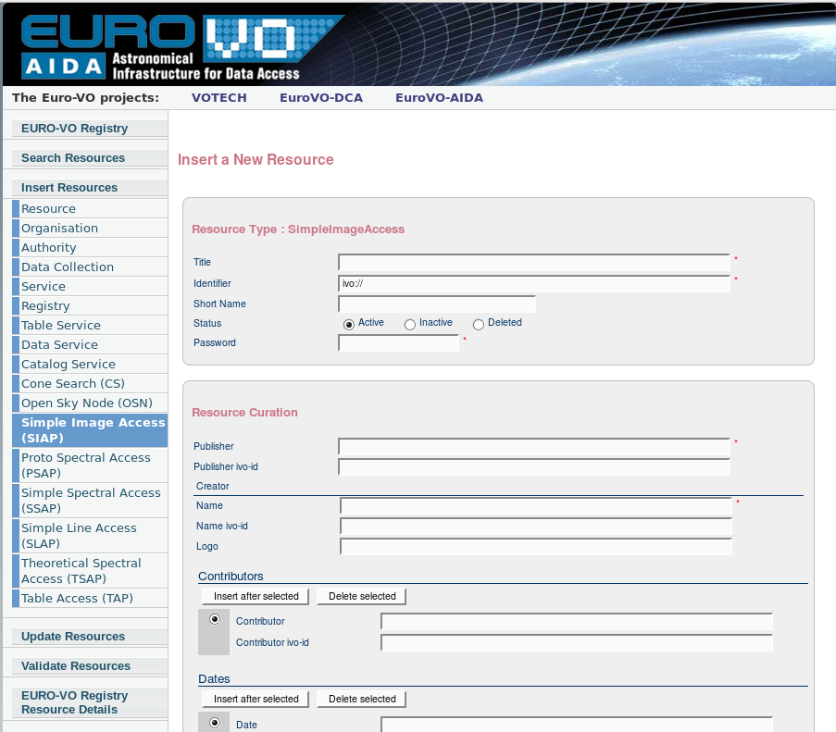
Figure 12.

